Çağdaş Bilecen - 2014510015

AUGMENTED RB-TREE

1. What is Augmented Red-Black Tree?

Augmented Red-Black Tree is extended version of Red-Black Tree. It has an additional information compared to Red-Black Tree which is number of younger nodes. All other features are same with Red-Black Tree. The information of number of younger nodes offers an advange to us that is, we can get this information from tree with less than O(logn), according to node's (which is given input from the user) position in Augmented Red Black Tree, when some node inserted to tree. Because this information is always will be updated when insert operation executed. In user interface, if some admin insert some node to tree, informationUpdater function will be called and executed respectively.

2. Augmented Tree's Different Methods & Attributes From Red-Black Tree

Figure 1.0 Additional Field Attribute Of Node Class
Augmented Red-Black Tree.Node class one additional field which is countOfYoungerNodes attribute. This variable keeps number of smallest nodes. To calculate this feature of tree, there is some extra functions as shown below:
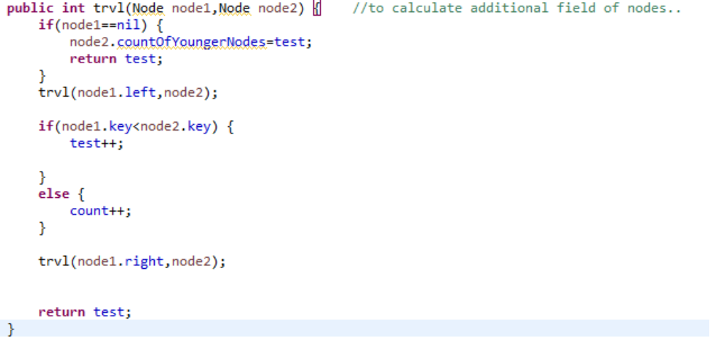
Figure 1.1 trvl() function
This function is called from trvl2 function (as shown Figure 1.3) and set countOfYoungerNodes for given node, with scan all the tree.

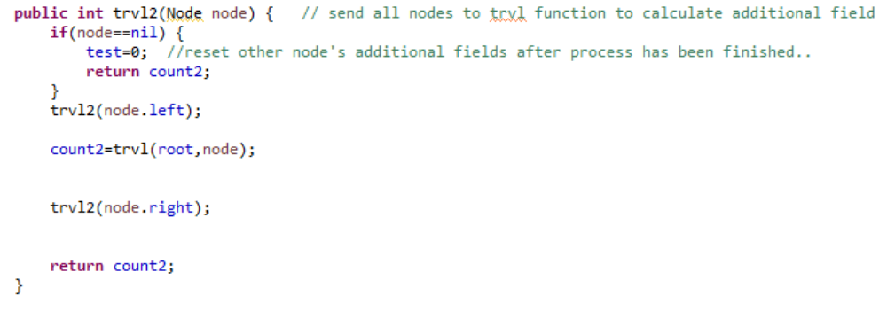
Figure 1.2 trvl2() function to send nodes to trvl()

As seen above, trvl2() send all the nodes of Augmented Tree to trvl() and calculate additional field value for every nodes. This function calls trvl1, so all the job is call trvl2() after every insertion operation as shown below (Figure 1.3).

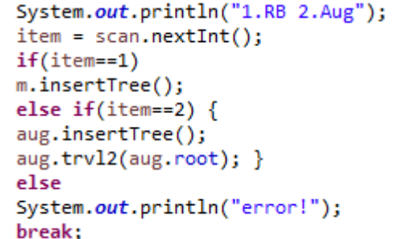
Figure 1.3 Invoking trvl2() after insertion operation.

3. Advantages & Disadvantages

  - Advantages

- It lets you take advantage of a clever stock data structure that almost, but not quite, solves your problem, and add that finishing touch that makes it do the trick.
- If you want to search by index too, not only by value, as you would do in an array. Then you add a new information to each node (which is number of younger persons): the size of the sub-tree rooted at its left child. You get something that allows for index lookup in O(lg n) time.
- In each of the situations above, simply adding the new information or constraints is not enough. You must ensure they are preserved through the maintenance process, when elements are added, removed or updated. That's why you must know a data structure well before trying to augment it. The augmentation must play well with the existing structure, otherwise the properties that make the new solution useful won't hold.

  - Disadvantages

- If we do not want to this information which is explained in below, we have unnecessary cost on this program.
- Because of calling O(logn) tree travaling function after all insertion, this is not a excellent solution to keep this information. More efficient solutions can be developed.

